**Syndicate**

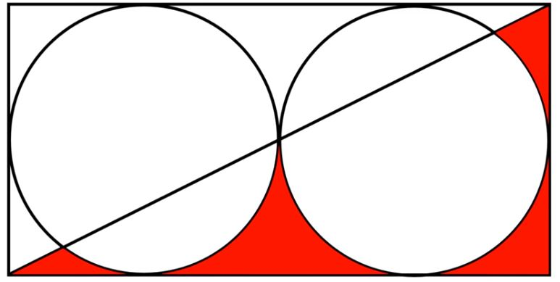

W

H

There are two big cricket grounds in Pahartoli side by side as shown in the picture. There are two syndicate committees who want to keep their dominance in Pahartoli. So they decided to seize the area around the cricket grounds. So they came to a conclusion that each committee will seize exactly half the area around the grounds (See the diagram for clarity). One committee will seize the red marked area shown in the picture.

The place is like a rectangle with dimensions **H** and **W** as shown in the picture. The rectangle has one of its diagonals connected. Inside the rectangle there are two circles of **equal size** which are tangent to each other and tangent to the rectangle.

Now one of the committee wants to find the area that will be seized by them. So they kidnapped you to find the area. If you can solve it, they will release you.

So there is no option for you other than helping them. So find the red marked area.

**INPUT**

The first line contains one integer H ( 0 < H < 109) - width of the rectangle.

**OUTPUT**

Print the red marked area.

Error less than 10-6 will be ignored

**Sample input**

2

**Sample output**

0.858407